**ASSIGNMENT 5**

1. Write a program to print MySirG N times on the screen.

**Ans.** //program to print MySirG N times on the screen

#include<stdio.h>

#include<conio.h>

main()

{

int i,n;

printf("Number of times do you want to print MySirG");

scanf("%d",&n);

for(i=1; i<=n; i++)

{

printf("MySirG\n");

}

getch();

}

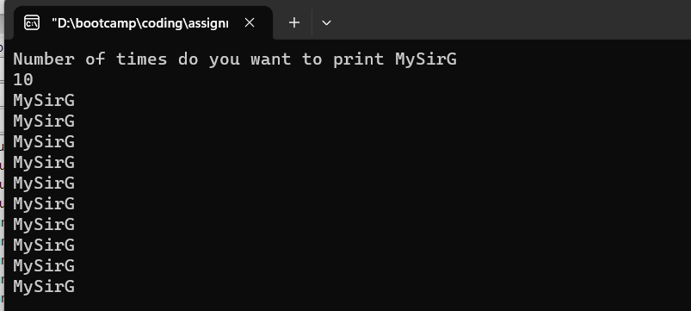

1. Write a program to print the first N natural numbers.

**Ans**. //program to print the first N natural numbers.

#include<stdio.h>

#include<conio.h>

main()

{

int i,n;

printf("first n natural number are:");

scanf("%d",&n);

for(i=1; i<=n; i++)

{

printf("%d\t",i);

}

getch();

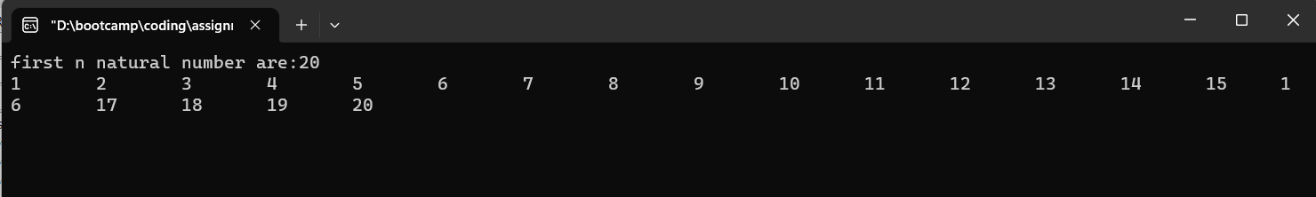}

1. Write a program to print the first N natural numbers in reverse order

**Ans.** //program to print the first N natural numbers in reverse order

#include<stdio.h>

#include<conio.h>

main()

{

int i,n;

printf("first n natural number in reverse order are:");

scanf("%d",&n);

for(i=n; i>=1; i--)

{

printf("%d\n",i);

}

getch();

}

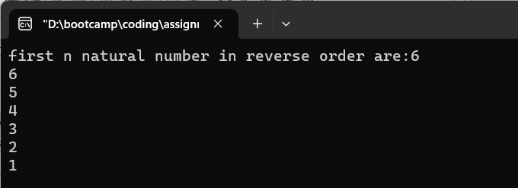

1. Write a program to print the first N odd natural numbers

**Ans.** // program to print the first N odd natural numbers

#include<stdio.h>

#include<conio.h>

main()

{

int i,n;

printf("enter the number which you like to find all the odd number are");

scanf("%d",&n);

for(i=1; i<=n; i++)

{

if(i%2!=0)

printf("%d\t",i);

}

getch();

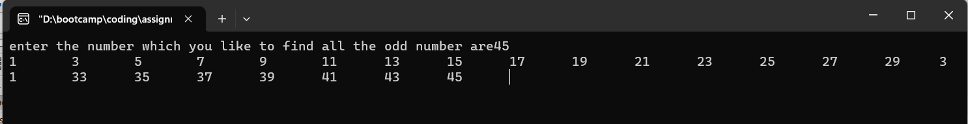}

1. Write a program to print the first N odd natural numbers in reverse order.

**Ans.** //program to print the first N odd natural numbers in reverse order.

#include<stdio.h>

#include<conio.h>

main()

{

int i,n;

printf("enter the number which you like to find all the odd number are");

scanf("%d",&n);

for(i=n; i>=1; i--)

{

if(i%2!=0)

printf("%d\t",i);

}

getch();

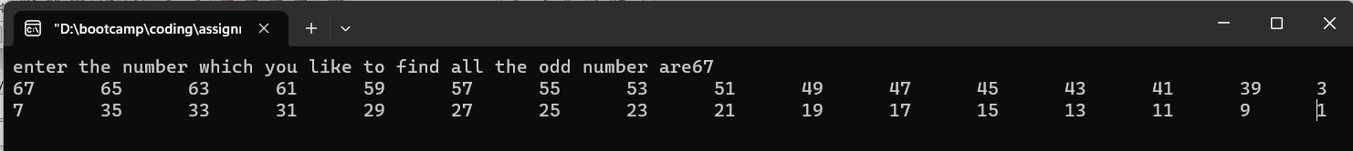}

1. Write a program to print the first N even natural numbers

**Ans.**  //program to print the first N even natural numbers

#include<stdio.h>

#include<conio.h>

main()

{

int i,n;

printf("enter the number which you like to find all the even number are");

scanf("%d",&n);

for(i=1; i<=n; i++)

{

if(i%2==0)

printf("%d\n",i);

}

getch();

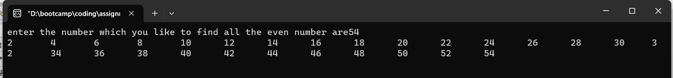}

1. Write a program to print the first N even natural numbers in reverse order

**Ans.** //program to print the first N even natural numbers in reverse order

#include<stdio.h>

#include<conio.h>

main()

{

int i,n;

printf("enter the number which you like to find all the odd number are");

scanf("%d",&n);

for(i=n; i>=1; i--)

{

if(i%2==0)

printf("%d\n",i);

}

getch();

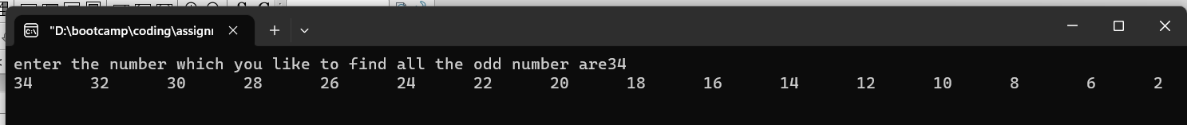}

1. Write a program to print squares of the first N natural numbers

**Ans.**  //Write a program to print squares of the first N natural numbers

#include<stdio.h>

#include<conio.h>

main()

{

int i,n;

printf("Enter the number");

scanf("%d",&n);

for(i=1; i<=n; i++)

{

printf("%d*%d=%d\n",i,i,i*i);

}

getch();

}

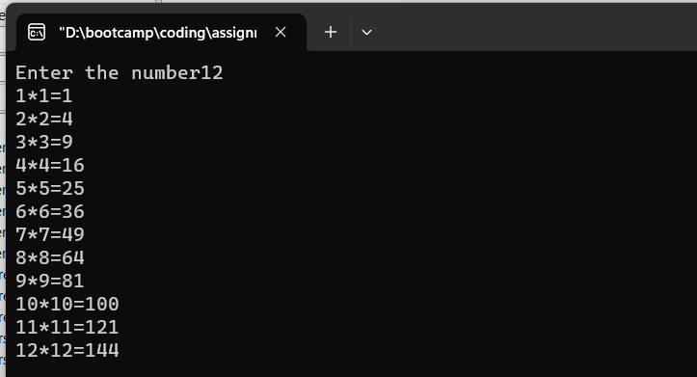

1. WAP to print cubes of the first N natural numbers.

Ans. //program to print cubes of the first N natural numbers

#include<stdio.h>

#include<conio.h>

main()

{

int i,n;

printf("Enter the number");

scanf("%d",&n);

for(i=1; i<=n; i++)

{

printf("%d*%d*%d = %d\n",i,i,i,i*i*i);

}

getch();

}

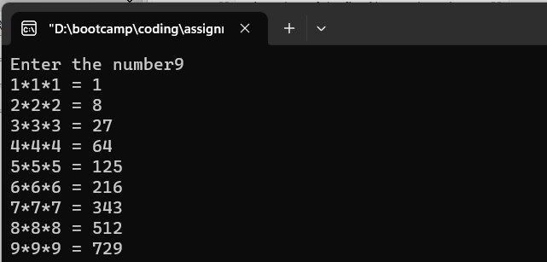

1. WAP to print a table of N.

**Ans.** //Program to print a table of N

#include<stdio.h>

#include<conio.h>

main()

{

int i,n;

printf("Enter the number");

scanf("%d",&n);

for(i=1; i<=10; i++)

{

printf("%d * %d = %d\n",n,i,n*i);

}

getch();

}

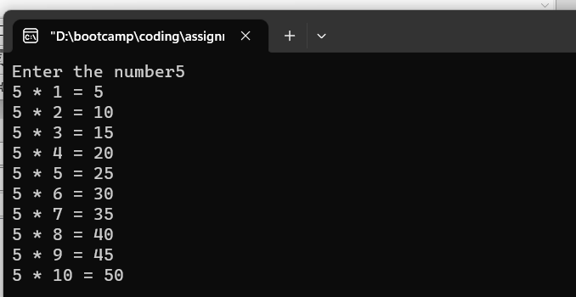

Thank You!!